**CMPE-250 Laboratory Exercise 3**

**Memory, Conditional Branching, and Debugging**

By submitting this report, I attest that its contents are wholly my individual writing about this exercise and that they reflect the submitted code. I further acknowledge that permitted collaboration for this exercise consists only of discussions of concepts with course staff and fellow students; however, other than code provided by the instructor for this exercise, all code was developed by me.

Joel Yuhas

Performed 2/10/2016

Submitted 2/17/2016

Lab Section 02

Instructor: Alessandro Sarra

TA: Peter Muller

Connor Goss

Stephen Moore

Lecture Section 250.01

Professor: Alessandro Sarra

**Documentation**

Screen Captures:

**Input Set 1: P = 23, Q = -6 , R =18**

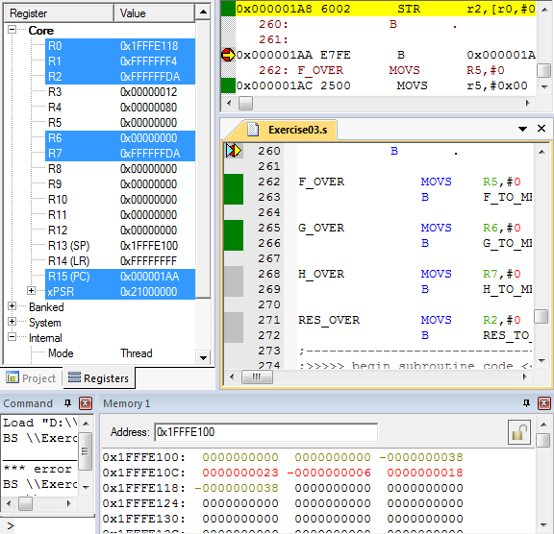

**Input Set 2: P = -3, Q = -4, R = 5**

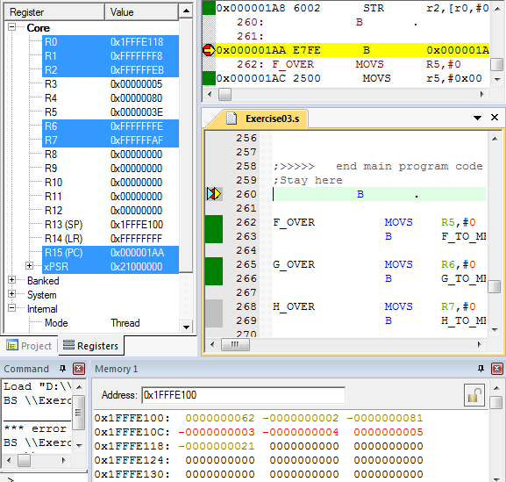

Question:

Could you reduce or eliminate overflow by changing the order of operations within the expression? Explain

No, overflow would not be able to reduce or eliminate overflow in this scenario. The only instance where changing the order of operations would slow down overflow is in equation G, input source 2. If the result of P and P’s scalar multiple were subtracted from by R and R’s scalar multiple than it would delay an overflow, but the rest of the equation would add together and result in an overflow.

All other equations would not be impacted by changing the order of operations because overflow would happen as a result from adding the equation together in its entirety, or doesn’t reach the overflow threshold at all.

In conclusion, changing the order of operations would have no impact on whether or not an equation reaches overflow.